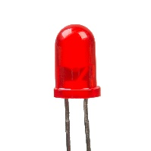

**Push Button**

**Vibration Sensor SW-420**

**LED**

**GPS NEO 6M**

**Accelerometer MPU-6050**

**5V**

**Lithium-ion Rechargeable Battery Pack 18650 2S 7.4V**

**7.4V**